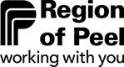
Find the Hidden Water Message!
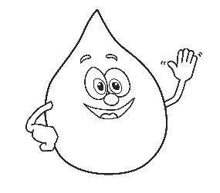
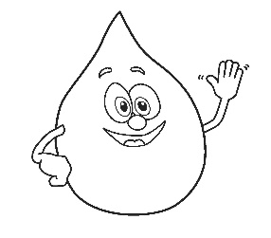
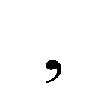

4

5

16

1

15

6

5

23

1

20

5

18

20
This Photo by Unknown Author is licensed under CC BY-SA

3

12

5

1

14

9

19

1

14

4

19

1

7

15

6

15

18

20

8
1 | A
2 | B
3 | C
4 | D
5 | E
6 | F
7 | G
8 | H
9 | I
10 | J
11 | K
12 | L
13 | M
14 | N
15 | O
16 | P
17 | Q
18 | R
19 | S
20 | T
21 | U
22 | V
23 | W
24 | X
25 | Y
26 | Z
Answer: Tap water is clean, safe and good for the environment

5

14

22

9

18

15

14

13

5

14

20

