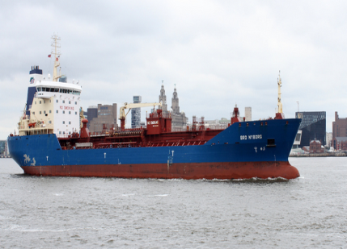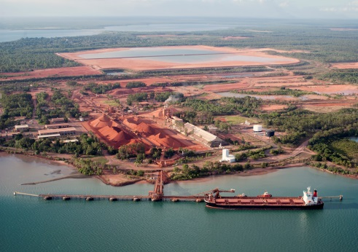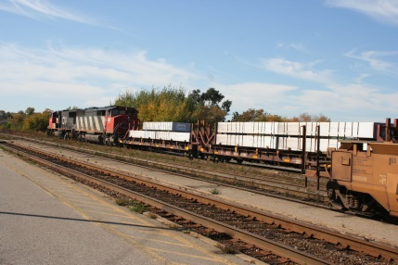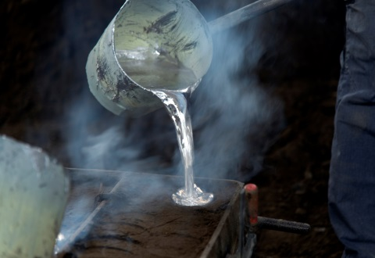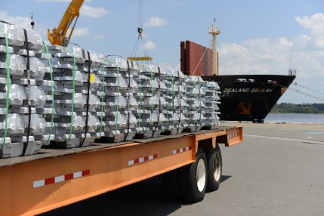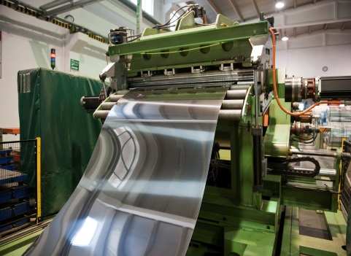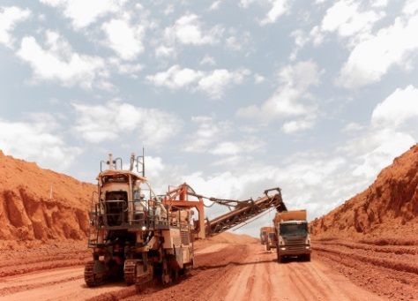

**4) Transporting Aluminum OXIDE**

**The Lifecycle of an Aluminum Can**

**5) Smelting Aluminum**

**7) Rolling Aluminum**

**3) Refining Bauxite**

**2) Transporting Bauxite**

**1) Mining Bauxite**

**12) Distributing Cans**

**11) Filling Cans**

**9) Manufacturing Cans**

**6) Transporting Aluminum ingots**

Canada is the world's fourth largest producer of aluminum – but Canada does not have any bauxite mines. The majority of the world’s bauxite is mined in Australia, Brazil, Guinea, and Jamaica – and then must be transported to Canada for processing.

Aluminum is found in the earth’s crust as bauxite ore. Bauxite is typically mined in open-pit mines or strip mines.

Strip mining involves removing a deep layer of soil to get to the bauxite ore. This requires removing vast areas of forest.

Open pit mining is used where bauxite is found deeper in the ground. Explosives are used to break up the soil or rock, and gradually a deep pit forms.

On average, 5 tonnes of bauxite ore are required to produce 1 tonne of aluminum.

Aluminum oxide must be converted into pure aluminum before it can be used. This is done using electricity and chemicals in an aluminum smelter.

Aluminum smelters produce molten aluminum, which is cast into solid shape called ingots.

Smelting and casting 1 tonne of aluminum requires 55300 megajoules of electricity, as well as 1294 megajoules of heat energy from fossil fuels like coal and natural gas.

Aluminum smelters produce toxic gases, including Tetrafluoromethane (a powerful greenhouse gas) and benzo[a]pyrene (a Class 1 carcinogen).

To produce aluminum, bauxite ore is crushed and mixed with strong chemicals (sodium carbonate and sodium hydroxide). It is then heated and undergoes chemical changes, creating aluminum oxide and a hazardous byproduct known as ‘red mud’.

‘Red mud’ contains sodium hydroxide, and is strong enough to kill plant and animal life. It can cause burns and the fumes can damage airways.

Most refineries collect the mud in open ponds in an attempt to prevent it from contaminating the environment while it slowly dries out. For every tonne of aluminum produced, between 0.6 to 4 tonnes of red mud are created.

Aluminum oxide is transported from the refinery to the aluminum smelter.

Aluminum ingots are transported to the rolling mills.

At the rolling mill, the aluminum ingots are preheated to about 1000°F and fed through a hot mill where they are rolled back and forth until they are ¼ inch in thickness.

Once cold, they are fed through another round of rollers that reduce the thickness to 0.012 inches as required by the can manufacturers.

Producing 1 tonne of can sheet requires 3077 megajoules of heat from burning natural gas, as well as 1025 megajoules of electricity. It also produces 1.7 kg of toxic gases, and over 2 tonnes of polluted wastewater.

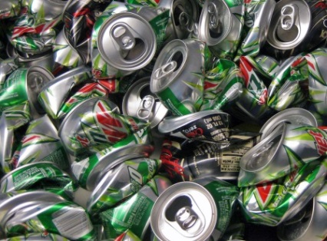

**10) Transporting Empty cans**

If thrown in the garbage, aluminum cans would be transported to landfill.   
  
Garbage from Peel homes is trucked to a landfill in Warwick, Ontario, a 2-hour drive away. Garbage is first compacted into transport trucks at waste transfer stations to reduce the number of trucks needed to haul the waste.

**14) Transporting**

**USED CANS**

**15) Disposal of Cans**

**13) Purchasing Cans & Consuming Product**

**8) Transporting rolls of aluminum**

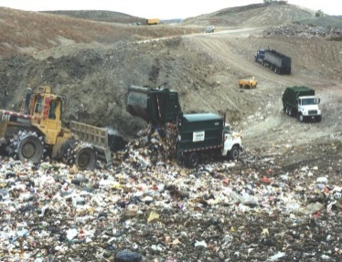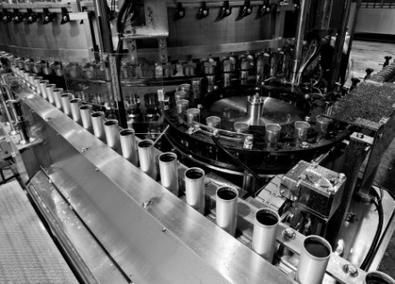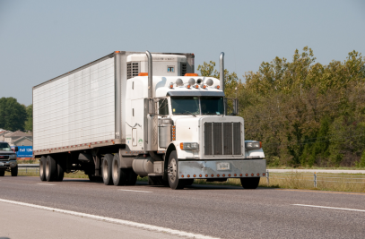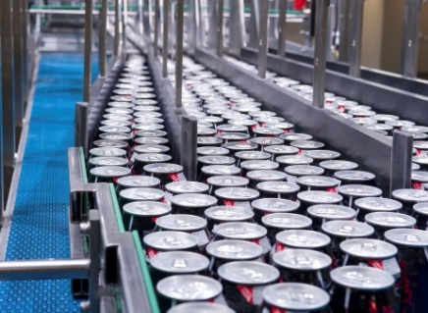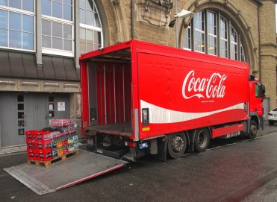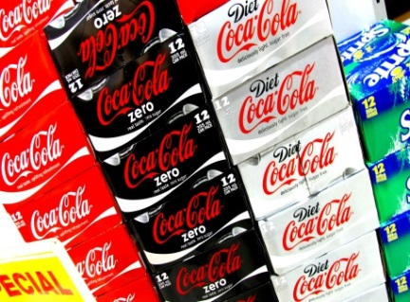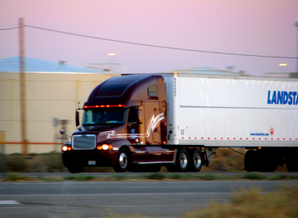

Scientists estimate that it takes hundreds of years for an aluminum can to disintegrate.

In Ontario only 40% of aluminum beverage cans are put into the recycling. As a result, Ontarians send approximately one billion aluminum cans to landfills each year.

At the beverage factory, the aluminum cans travel on conveyor belts and are filled with juice, soda, or other beverages.

The full cans are trucked to distribution centers, and finally to supermarkets.

1.8 billion aluminum beverage cans are purchased in Ontario each year.

At a factory, aluminum sheets are stamped, pressed and coated to create cans.

Forming 1000 cans uses 404.5 megajoules of electricity and 16.78 kg of aluminum sheet.

Aluminum can factories release greenhouse gases like carbon dioxide, in addition to air pollutants such as carbon monoxide, nitrogen oxides, and sulphur dioxide.

Cans are stacked on pallets, packaged, and shipped on transport trucks to the beverage factory.

Coiled sheets of aluminum are shipped from the rolling mills to can manufacturing plants.

**Information sources:** Life Cycle Impact Assessment of Aluminum Beverage Cans (2010) by PE Americas for Aluminum Association, Inc. at <http://www.container-recycling.org/assets/pdfs/aluminum/LCA-2010-AluminumAssoc.pdf>. Beverage Container Recovery in Ontario: Achieving Greater Performance and Sustainability by Canadian Beverage Container Recycling at <http://www.wdo.ca/Portals/0/Document_Folder/CBCRA_Beverage_Container_Draft_ISP.pdf>. Can Manufacturer’s Institute - <http://w.cancentral.com/>. Region of Peel Waste Division.

**Creative Commons image sources:** Norsk Hydro ASA <https://flic.kr/p/hJrRHJ>; Tharrin <https://flic.kr/p/6hGmxu>; Joe Loong <https://flic.kr/p/866sfq>; Rennett Stowe <https://flic.kr/p/5pxb2S>; Ian <https://flic.kr/p/cAxhdS>; ladybugkreativ https://pixabay.com/en/coca-cola-cola-drink-transport-980617/