Activity: The Lifeline of your Lunchbox

Objective
Students’ will investigate the time that it takes for common lunch items to decompose if they are not put in the proper waste bins. Through this activity, they will discuss how proper waste disposal in the Region of Peel benefits Ontario and Canada as a whole.

Preparation
Materials:
- Decomposition Timeline – Appendix A
- Images of timeline materials – Appendix B
- Technology to play video: Juice boxes - http://www.pbslearningmedia.org/resource/lpsc10.sci.life.jcbx/juice-boxes/
- Paper (one sheet per group)

Discuss with students’ what ‘decomposition’ means.
- Follow-up by asking how long they think it takes for lunch packaging waste to decompose in a landfill (Days, years, etc.)
Show students the video
- Tell students they will be watching a video about an item that takes over 300 years to decompose in a landfill
- Play “Juice Boxes” video (2:20)
- Ask students if they were surprised by how long it takes for a juice box to decompose in a landfill

Activity
- Lunchbox Timeline:
- Place students into groups of 3-4 students and hand out pictures of lunch items to each group.
- Ask them to organize the items from least amount of time to decompose to longest amount of time to decompose.
- On the sheet of paper, have groups write down a table with 2 columns – Estimate and Actual. Have students record each of their items in the rows.
- While they are completing their timelines, they must record guesses for how long it takes each item to decompose in line with the visual placement of their flyer items using the knowledge from the juice box video as their benchmark point.
- Give students 10 minutes to complete their mini timeline and record their estimates.
- Present Lunchbox Timeline:
- Have each group present their timeline and estimates for each item.
- After each group has presented, reveal the actual timeline from Appendix A.
- Discuss observations – How close were the students to the actual timeline? Why does it take so long for some lunch items to decompose?
- Ask students:
- Thinking back to the beginning of the lesson, how does the amount of time it takes for lunch waste to decompose in a landfill compare to the amount of time it takes to eat your lunch?

- Debrief Questions:
- Which item had the most surprising timeline?
- Which items were biotic? Which items were abiotic? Did this have an impact on the decomposition timeline?
- How can we reduce the timeline of these materials? (Use recycling bin in the school, reduce consumption of items, use reusable containers, and buy bulk items, educate friends and family about littering and proper recycling in the Region of Peel)
- How does proper waste sorting in the Region of Peel affect Ontario? Canada?
- What action can we take as a class to ensure no recyclable materials end up in a landfill?
- Further reading: https://www.cbc.ca/kidscbc2/the-feed/how-long-does-your-trash-last

Appendix A - Table 1. Decomposition Timeline for Lunch Items
*Note: these times depend on landfill conditions.
Item | Time | Item | Time
Banana Peel | ~5 – 20 years | Plastic ‘Lunchmate’ Tray | 500+ years
Paper | ~10 – 40 years | Plastic Yogurt Cup | 500+ years
Cotton T-shirt | ~ 10 – 40 years | Plastic Juice Bottle | 500+ years
Popsicle Stick | 30 – 90 years | Glass Bottle | 1,000,000 years
Aluminum and/or Steel Fruit Cup Can | 80-100 years | Styrofoam Cup | Unknown/Forever

Sources
1. Intergovernmental Panel on Climate Change (2006) Guidelines for National Greenhouse Gas Inventories - Volume
5 – Waste at http://www.ipcc-nggip.iges.or.jp/public/2006gl/vol5.html
& Florentino B. De la Cruz and Morton A. Barlaz (May 2010). Estimation of Waste Component-Specific Landfill Decay Rates Using Laboratory-Scale Decomposition Data. Environ. Sci. Technol., 2010, 44 (12), pp 4722–4728
2. Humes, Edward (2012). Garbology: Our Dirty Love Affair with Trash.
3. Rathje, William L. (May 1991). Once and Future Landfills. National Geographic 1991, 179,116-34.
4. Lili Li, Margaret Frey, Kristie J Browning (2010). Biodegradability Study on Cotton and Polyester Fabrics. Journal
of Engineered Fibers and Fabrics. Volume 5, Issue 4 – 2010. http://jeffjournal.org/papers/Volume5/5-4-6Frey.pdf
5. F.A. Ximenes, W.D. Gardner, A.L. Cowie (2008). The decomposition of wood products in landfills in Sydney,
Australia. Waste Management 28 (2008) 2344–2354
6. M. Sinan Bilgili, Ahmet Demir, Mahir Ince, Bestamin Ozkaya (2007). Metal concentrations of simulated aerobic
and anaerobic pilot scale landfill reactors. Journal of Hazardous Materials 145, pp186–194.
7. National Geographic Society (2015). By the Numbers. Washington, D.C.
8. American Chemical Society (2009). Plastics in oceans decompose, release hazardous chemicals, surprising new
study says. https://www.acs.org/content/acs/en/pressroom/newsreleases/2009/august/plastics-in-oceans-decompose-release-hazardous-chemicals-surprising-new-study-says.html
& Barry, Carolyn (2009). Plastic Breaks Down in Ocean, After All -- And Fast. National Geographic News. http://news.nationalgeographic.com/news/2009/08/090820-plastic-decomposes-oceans-seas.html
9. Glenza, Jessica (September 8, 2017). Sea salt around the world is contaminated by plastic, studies show. The
Guardian, UK. https://www.theguardian.com/environment/2017/sep/08/sea-salt-around-world-contaminated-by-plastic-studies
10. David K. A. Barnes, Francois Galgani, Richard C. Thompson and Morton Barlaz (2009). Accumulation and
fragmentation of plastic debris in global environments. Philosophical Transactions of the Royal Society B., 2009, 364, pp 1985–1998
11. Hayden K. Webb, Jaimys Arnott, Russell J. Crawford and Elena P. Ivanova (2013). Plastic Degradation and Its
Environmental Implications with Special Reference to Poly(ethylene terephthalate). Polymers 5(1), 1-18.
12. R. Pramila and K. Vijaya Ramesh (2011). Biodegradation of low density polyethylene (LDPE) by fungi isolated
from marine water– a SEM analysis. African Journal of Microbiology Research Vol. 5(28), pp. 5013-5018, 30 November 2011 http://www.academicjournals.org/AJMR ISSN 1996-0808
13. A. J. Shortland, M.S. Tite (2000). Raw Materials of Glass from Amarna and Implications for the Origins of
Egyptian Glass. Achaeometry, February 2000 Volume 42, Issue 1, Pages 141–151
14. Arshad, K., Skrifvars, M., Vivod, V., Valh, J., & Voncina, B. (2014). Biodegradation of natural textile materials in
soil. Tekstilec, 57(2), 118–132. https://doi.org/10.14502/Tekstilec2014.57.118-132

Appendix B – Images of timeline materials
*see next page

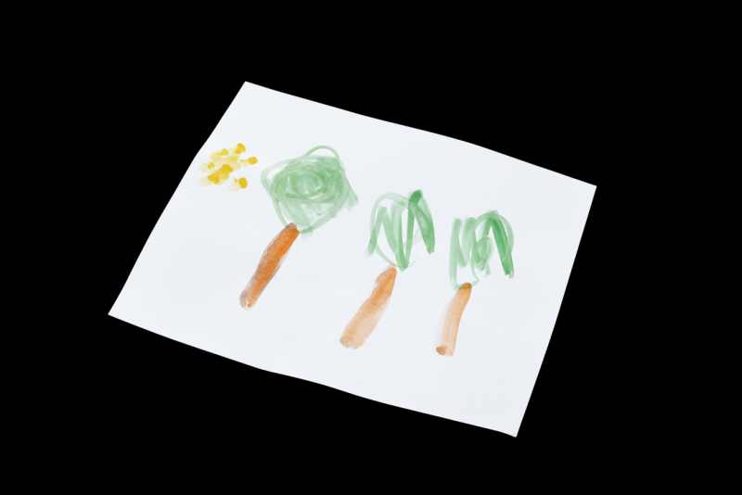
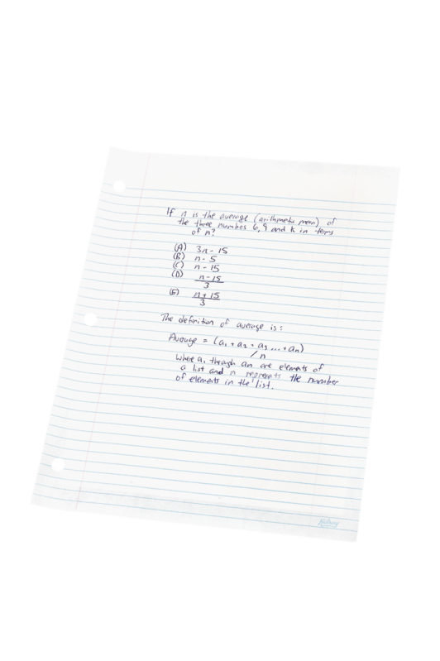
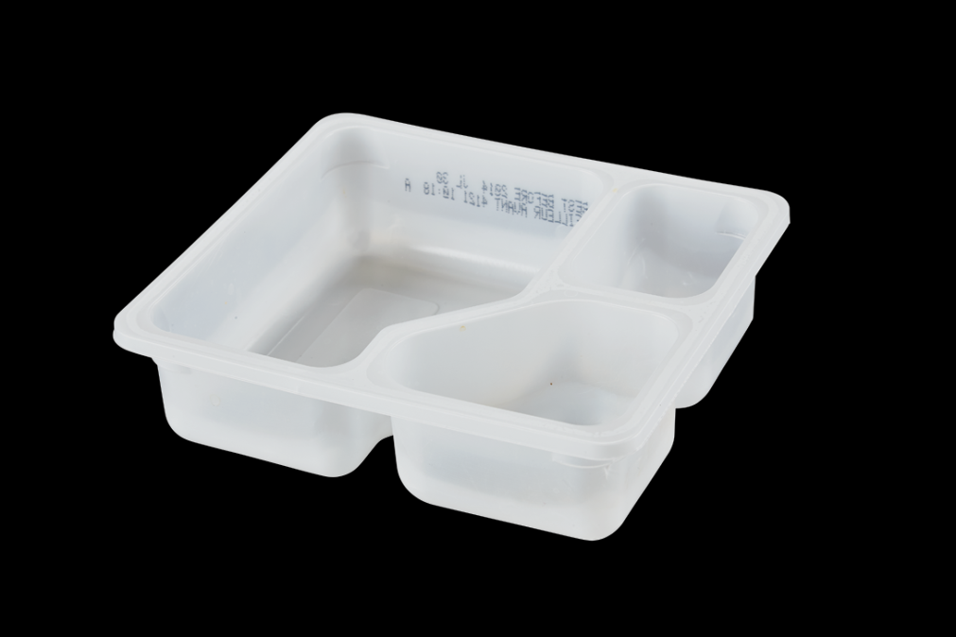
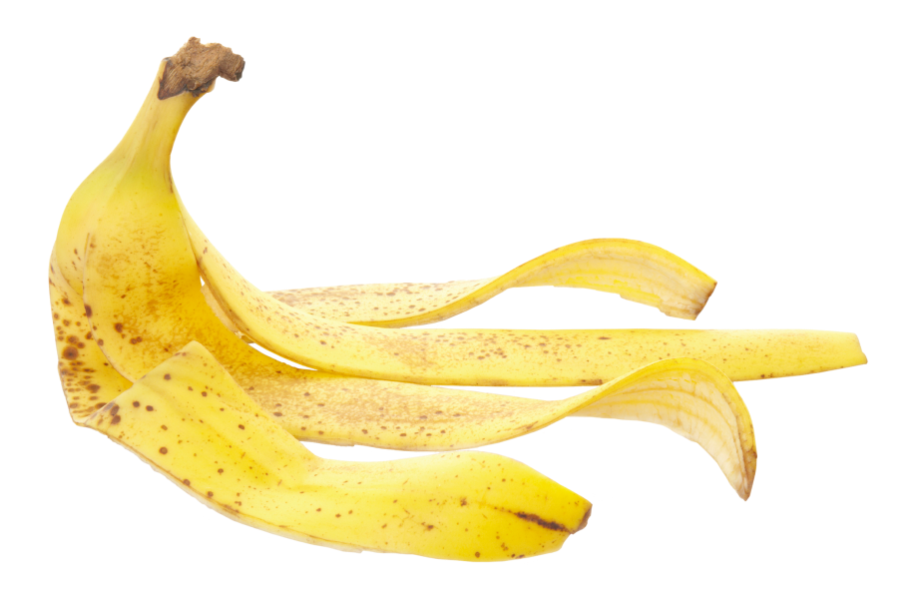
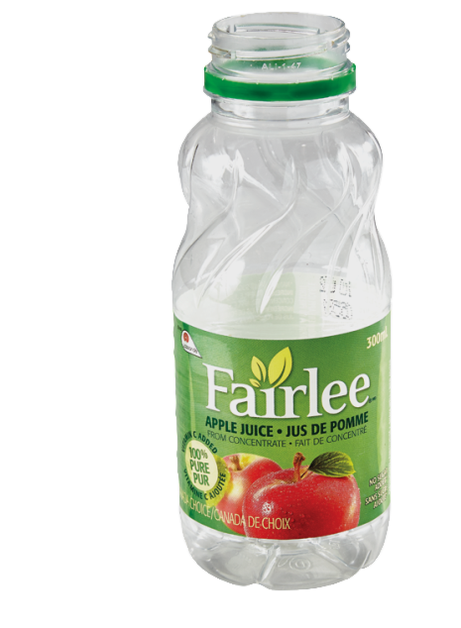
popsicle stick
paper
Styrofoam™ cup
LunchMates™ plastic tray
plastic bottle
banana peel
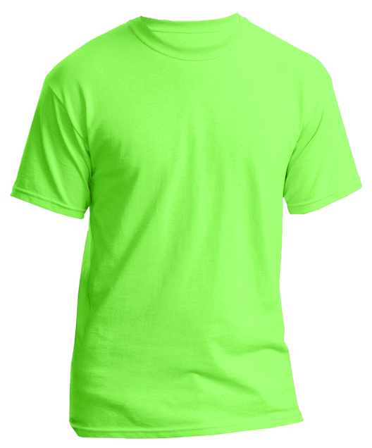
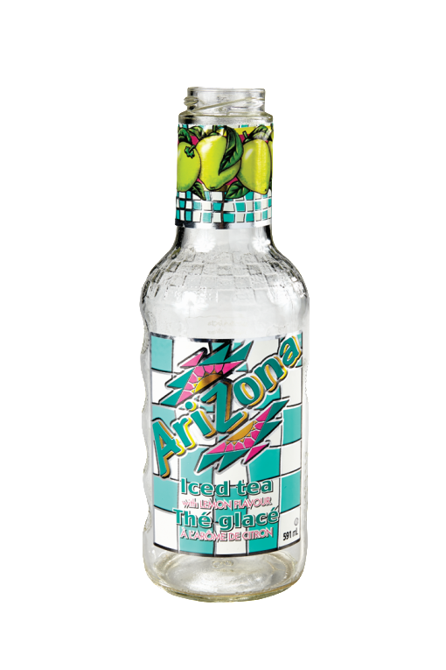
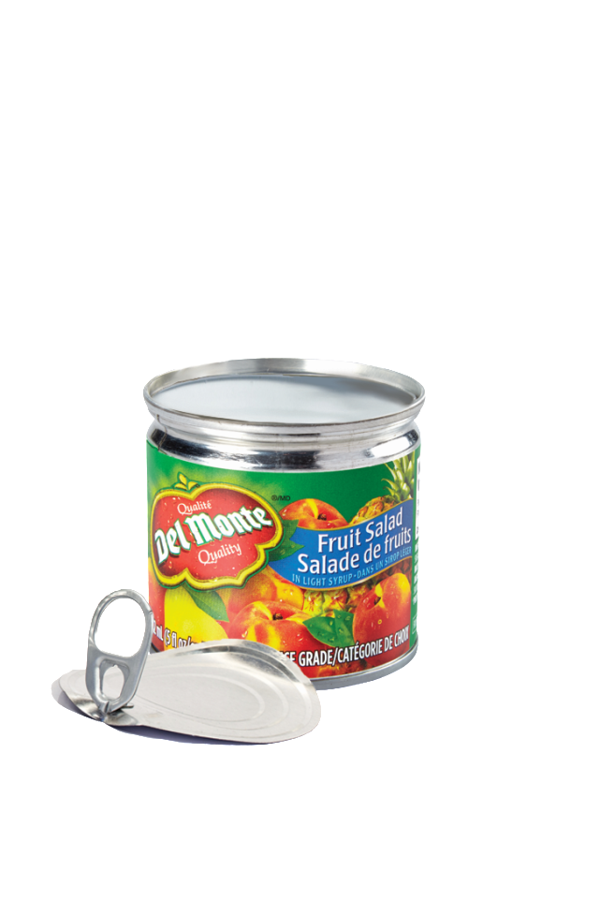
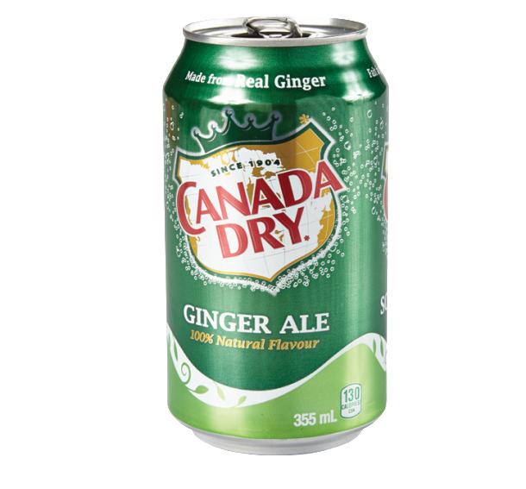
glass bottle
aluminum can
steel can
cotton t-shirt

